**Activation Functions Derivatives Logic**

[Here](https://www.tensorflow.org/api_docs/python/tf/keras/activations) is the list of all the activation functions of Tensorflow.

Common math for all the developments that follow:

$t_{in}$ is the input sent to the activation function.

$t_{out}$ is the output obtained from the activation function.

Once we have the slope of the tangent function (u), we then proceed to get the independent term. So that:

$$t_{out}=u∙t_{in}+v → v= t_{out}-u∙t_{in}$$

Thus:

[**elu(...)**](https://www.tensorflow.org/api_docs/python/tf/keras/activations/elu)**: Exponential Linear Unit**

**Definition:**

$$if t_{in}<0: t_{out}=alpha∙\left(e^{t_{in}}-1\right)$$

$$if t_{in}<0: t_{out}=t_{in}$$

**Derivative:**

$$if t_{in}<0:$$

$$u=alpha∙e^{t_{in}}=t_{out}+alpha$$

$v= t_{out}-u∙t_{in}$

$$else:$$

$$u, v=1, 0$$

**Code:**

# Elu:

def af_elu(af_in, af_out, alpha=1):

if af_in<0:

u = af_out + alpha

v = af_out - u*af_in

else:

u, v = 1, 0

return u, v

[**exponential(...)**](https://www.tensorflow.org/api_docs/python/tf/keras/activations/exponential)**: Exponential activation function.**

**Definition:**

$$t_{out}=e^{t_{in}}$$

**Derivative:**

$$u=e^{t_{in}}$$

$$v= t_{out}-u∙t_{in}$$

**Code:**

# Exponential:

def af_exp(af_in, af_out):

u = af_out

v = af_out - u*af_in

return u, v

[**gelu(...)**](https://www.tensorflow.org/api_docs/python/tf/keras/activations/gelu)**: Applies the Gaussian error linear unit (GELU) activation function.**

**Definition:**

$$if approximate is True: t_{out}=0.5∙t_{in}∙\left(1+tanh\left(\sqrt{\frac{2 }{π}}∙\left(t_{in}+0.044715∙{t_{in}}^{3}\right)\right)\right)$$

$$else: t_{out}=0.5∙t_{in}∙\left(1 + erf\left(\frac{t_{in}}{ \sqrt{2}}\right)\right)$$

**Derivative:**

Luckily, we can obtain the derivative of the erf() directly through the  [Fundamental Theorem of Calculus (First Part)](https://proofwiki.org/wiki/Derivative_of_Error_Function). Also see [Wikipedia](https://en.wikipedia.org/wiki/Error_function):

$$\frac{∂ erf\left(x\right)}{∂x}=\frac{2}{\sqrt{π}}e^{-x^{2}}$$

Our argument of the erf() has a factor $\frac{1}{ \sqrt{2}}$, one can apply the chain rule to obtain the derivative of this calling $β=\frac{t }{ \sqrt{2}}$:

$$\frac{∂erf\left(\frac{t }{ \sqrt{2}}\right)}{∂t}=\frac{∂erf\left(β\right)}{∂t}=\frac{∂ erf\left(β\right)}{∂β}\frac{∂β}{∂t}=\left(\frac{2}{\sqrt{π}}e^{-β^{2}}\right)\left(\frac{1 }{ \sqrt{2}}\right)=\frac{2}{\sqrt{2π}}e^{-{(t}^{2})/2 }$$

Let us differentiate $t_{out}$ with respect to $t_{in}$:

$$u=0.5∙\left(1 + erf\left(\frac{t_{in} }{ \sqrt{2}}\right)\right)+0.5∙t_{in}∙\left(\frac{2}{\sqrt{2π}}e^{-{(t_{in}}^{2})/2 }\right)$$

Regardless of the value of approximate, we can replace the first term of u by $\frac{t_{out}}{t_{in}}$:

$$u=\frac{t_{out}}{t_{in}}+\frac{t_{in}}{\sqrt{2π}}e^{-{(t_{in}}^{2})/2 }$$

Then:

$$v= t_{out}-u∙t_{in}$$

**Code:**

# Gelu:

def af_gelu(af_in, af_out):

u = af_out/af_in + (af_in/(np.sqrt(2*np.pi()))) * np.exp( - (af_in**2)/2 )

v = af_out - u*af_in

return u, v

[**hard_sigmoid(...)**](https://www.tensorflow.org/api_docs/python/tf/keras/activations/hard_sigmoid)**: Hard sigmoid activation function.**

**Definition:**

$if t_{in}<-2.5: t_{out}=0$

$$if -2.5≤t_{in}≤2.5: t_{out}=0.2∙x+0.5$$

$$if 2.5<t_{in}: t_{out}=1$$

**Derivative:**

$$if t_{in}<-2.5: u, v=0, 0$$

$$if -2.5≤t_{in}≤2.5: u,v=0.2, 0.5$$

$$if 2.5<t_{in}: u, v=0, 1$$

**Code:**

# Hard Sigmoid:

def af_hardsigmoid(af_in, af_out):

if af_in<-2.5:

u, v = 0, 0

elif 2.5<af_in:

u, v = 0, 1

else:

u, v = 0.2, 0.5

return u, v

[**linear(...)**](https://www.tensorflow.org/api_docs/python/tf/keras/activations/linear)**: Linear activation function (pass-through).**

**Definition:**

$t_{out}=t_{in}$

**Derivative:**

$$u, v=1, 0$$

**Code:**

# Linear:

def af_linear(af_in, af_out):

u, v = 1, 0

return u, v

[**relu(...)**](https://www.tensorflow.org/api_docs/python/tf/keras/activations/relu)**: Applies the rectified linear unit activation function.**

**Definition:**

$$if t_{out}≥max_value: t_{out}=max_value$$

$if threshold<t_{in}: t_{out}=t_{in}$

$$if t_{in}≤threshold: t_{out}=alpha∙t_{in}-alpha∙threshold$$

**Derivative:**

$$if t_{out}≥max_value: return u,v =0, max_value$$

$if threshold<t_{in}: u, v=1, 0$

$$if t_{in}≤threshold: u, v= alpha, -alpha∙threshold$$

**Code:**

# Relu:

def af_relu(af_in, af_out, alpha=0, max_value=np.inf, threshold=0):

if af_out >= max_value:

return 0, max_value

if threshold < af_in:

u, v = 1, 0

else:

u, v= alpha, -alpha*threshold

return u, v

[**selu(...)**](https://www.tensorflow.org/api_docs/python/tf/keras/activations/selu)**: Scaled Exponential Linear Unit (SELU).**

**Definition:**

$$if t_{out}≥0: t_{out}=scale∙t_{in}$$

$$if t_{out}<0: t_{out}=scale∙alpha∙\left(\exp\left(t_{in}\right)-1\right)$$

**Derivative:**

$$if t_{out}≥0: u, v=scale, 0$$

$$if t_{out}<0:$$

$$u=scale∙alpha∙\exp\left(t_{in}\right)$$

$$v=t_{out}-u∙t_{in}$$

**Code:**

# Selu:

def af_selu(af_in, af_out):

# alpha and scale are pre-defined constants:

alpha=1.67326324

scale=1.05070098

if af_in<0:

u = scale*alpha*np.exp(af_in)

v = af_out - u*af_in

else:

u, v = scale, 0

return u, v

[**sigmoid(...)**](https://www.tensorflow.org/api_docs/python/tf/keras/activations/sigmoid)**: Sigmoid activation function, sigmoid(x) = 1 / (1 + exp(-x)).**

**Definition:**

$$t_{out}=\frac{ 1 }{ \left(1 + exp\left(-t_{in}\right)\right)}$$

**Derivative:**

$$u=\frac{- 1 }{ {\left(1 + exp\left(-t_{in}\right)\right)}^{2}}\left[ -exp\left(-t_{in}\right)\right]=\frac{exp\left(-t_{in}\right)}{ {\left(1 + exp\left(-t_{in}\right)\right)}^{2}}=\frac{exp\left(-t_{in}\right)}{ {\left(1 + exp\left(-t_{in}\right)\right)}^{2}}=$$

$$=\frac{1}{ 1 + exp\left(-t_{in}\right)}\frac{exp\left(-t_{in}\right)}{ 1 + exp\left(-t_{in}\right)}=t_{out}\frac{exp\left(-t_{in}\right)}{ 1 + exp\left(-t_{in}\right)}=t_{out}\left(\frac{1+exp\left(-t_{in}\right)-1}{ 1 + exp\left(-t_{in}\right)}\right)=$$

$$=t_{out}\left(1- \frac{1}{ 1 + exp\left(-t_{in}\right)}\right)=t_{out}\left(1-t_{out}\right)$$

Then:

$$v=t_{out}-u∙t_{in}$$

**Code:**

# Sigmoid:

def af_sigmoid(af_in, af_out):

u = af_out*(1-af_out)

v = af_out - u*af_in

return u, v

[**softmax(...)**](https://www.tensorflow.org/api_docs/python/tf/keras/activations/softmax)**: Softmax converts a vector of values to a probability distribution.**

**Definition:**

Assuming we have $d$-dimensional input vector in the problem, and $N$ number of neurons in this softmax layer. Then, for each neuron $j$ of the layer we have a given input $t_{{in}_{j}}$ and an output $t_{{out}_{j}}$. We know that the input can be represented as a linear function as $t_{{in}_{j}}=\sum_{i=1}^{d+1}{μ_{i}^{j}∙x_{i}}$, where $μ_{i}^{j}$ are the coefficients of the linear function. To simplify, we are considering the independent term as the d+1 dimension, where $x_{d+1}=1$. Our goal is to find the new linear function that represents the output of the neuron $j$, which we will define as $t_{{out}_{j}}=\sum_{i=1}^{d+1}{ξ_{i}^{j}∙x_{i}}$. In other words, we need to find the $ξ_{i}^{j}$ coefficients.

Then,

$$t_{{out}_{j}}=\frac{e^{\left(t_{{in}_{j}}\right)}}{ e^{\left(t_{{in}_{1}}\right)}+…+e^{\left(t_{{in}_{j}}\right)}+…+e^{\left(t_{{in}_{N}}\right)}}=\frac{e^{\left(\sum_{i=1}^{d+1}{μ_{i}^{j}∙x_{i}}\right)}}{ e^{\left(\sum_{i=1}^{d+1}{μ_{i}^{1}∙x_{i}}\right)}+…+e^{\left(\sum_{i=1}^{d+1}{μ_{i}^{j}∙x_{i}}\right)}+…+e^{\left(\sum_{i=1}^{d+1}{μ_{i}^{N}∙x_{i}}\right)}}=$$

$$=e^{\left(\sum_{i=1}^{d+1}{μ_{i}^{j}∙x_{i}}\right)}∙{\left[e^{\left(\sum_{i=1}^{d+1}{μ_{i}^{1}∙x_{i}}\right)}+…+e^{\left(\sum_{i=1}^{d+1}{μ_{i}^{j}∙x_{i}}\right)}+…+e^{\left(\sum_{i=1}^{d+1}{μ_{i}^{N}∙x_{i}}\right)}\right]}^{-1}$$

**Derivative:**

$$A=e^{\left(\sum_{i=1}^{d+1}{μ_{i}^{j}∙x_{i}}\right)}$$

$$B={\left[e^{\left(\sum_{i=1}^{d+1}{μ_{i}^{1}∙x_{i}}\right)}+…+e^{\left(\sum_{i=1}^{d+1}{μ_{i}^{j}∙x_{i}}\right)}+…+e^{\left(\sum_{i=1}^{d+1}{μ_{i}^{N}∙x_{i}}\right)}\right]}^{-1}$$

$$ξ_{i}^{j}=\frac{∂t_{{out}_{j}}}{∂x_{i}}=B\frac{∂A}{∂x_{i}}+A\frac{∂B}{∂x_{i}}$$

Let us break the problem in two parts. First,

$$\frac{∂A}{∂x_{i}}=μ_{i}^{j}∙e^{\left(\sum_{i=1}^{d+1}{μ_{i}^{j}∙x_{i}}\right)}$$

$$B\frac{∂A}{∂x_{i}}=\frac{μ_{i}^{j}∙e^{\left(\sum_{i=1}^{d+1}{μ_{i}^{j}∙x_{i}}\right)}}{ e^{\left(\sum_{i=1}^{d+1}{μ_{i}^{1}∙x_{i}}\right)}+…+e^{\left(\sum_{i=1}^{d+1}{μ_{i}^{j}∙x_{i}}\right)}+…+e^{\left(\sum_{i=1}^{d+1}{μ_{i}^{N}∙x_{i}}\right)}}=μ_{i}^{j}∙t_{{out}_{j}}$$

Second,

$$\frac{∂B}{∂x_{i}}=- \frac{μ_{i}^{1}∙e^{\left(\sum_{i=1}^{d+1}{μ_{i}^{1}∙x_{i}}\right)}+…+μ_{i}^{j}∙e^{\left(\sum_{i=1}^{d+1}{μ_{i}^{j}∙x_{i}}\right)}+…+μ_{i}^{N}∙e^{\left(\sum_{i=1}^{d+1}{μ_{i}^{N}∙x_{i}}\right)}}{ {\left[e^{\left(\sum_{i=1}^{d+1}{μ_{i}^{1}∙x_{i}}\right)}+…+e^{\left(\sum_{i=1}^{d+1}{μ_{i}^{j}∙x_{i}}\right)}+…+e^{\left(\sum_{i=1}^{d+1}{μ_{i}^{N}∙x_{i}}\right)}\right]}^{2}}$$

$$A\frac{∂B}{∂x_{i}}=- e^{\left(\sum_{i=1}^{d+1}{μ_{i}^{j}∙x_{i}}\right)} \left\{\frac{μ_{i}^{1}∙e^{\left(\sum_{i=1}^{d+1}{μ_{i}^{1}∙x_{i}}\right)}+…+μ_{i}^{j}∙e^{\left(\sum_{i=1}^{d+1}{μ_{i}^{j}∙x_{i}}\right)}+…+μ_{i}^{N}∙e^{\left(\sum_{i=1}^{d+1}{μ_{i}^{N}∙x_{i}}\right)}}{ {\left[e^{\left(\sum_{i=1}^{d+1}{μ_{i}^{1}∙x_{i}}\right)}+…+e^{\left(\sum_{i=1}^{d+1}{μ_{i}^{j}∙x_{i}}\right)}+…+e^{\left(\sum_{i=1}^{d+1}{μ_{i}^{N}∙x_{i}}\right)}\right]}^{2}}\right\}=$$

$$=- t_{{out}_{j}} \left[\frac{μ_{i}^{1}∙e^{\left(\sum_{i=1}^{d+1}{μ_{i}^{1}∙x_{i}}\right)}+…+μ_{i}^{j}∙e^{\left(\sum_{i=1}^{d+1}{μ_{i}^{j}∙x_{i}}\right)}+…+μ_{i}^{N}∙e^{\left(\sum_{i=1}^{d+1}{μ_{i}^{N}∙x_{i}}\right)}}{ e^{\left(\sum_{i=1}^{d+1}{μ_{i}^{1}∙x_{i}}\right)}+…+e^{\left(\sum_{i=1}^{d+1}{μ_{i}^{j}∙x_{i}}\right)}+…+e^{\left(\sum_{i=1}^{d+1}{μ_{i}^{N}∙x_{i}}\right)}}\right]=$$

$$=- t_{{out}_{j}} \left[μ_{i}^{1}∙t_{{out}_{1}}+…+μ_{i}^{j}∙t_{{out}_{j}}+…+μ_{i}^{N}∙t_{{out}_{N}}\right]= -t_{{out}_{j}}\sum_{k=1}^{N}{μ_{i}^{k}∙t_{{out}_{k}}}$$

So, adding both terms,

$$\frac{∂t_{{out}_{j}}}{∂x_{i}}=B\frac{∂A}{∂x_{i}}+A\frac{∂B}{∂x_{i}}=μ_{i}^{j}∙t_{{out}_{j}}-t_{{out}_{j}}\sum_{k=1}^{N}{μ_{i}^{k}∙t_{{out}_{k}}}= t_{{out}_{j}}∙\left(μ_{i}^{j}-\sum_{n=1}^{N}{μ_{i}^{n}∙t_{{out}_{n}}}\right)$$

Thus, the $i$ th dependent term of the neuron $j$ is:

$$ξ_{i}^{j}= t_{{out}_{j}}∙\left(μ_{i}^{j}-\sum_{n=1}^{N}{μ_{i}^{n}∙t_{{out}_{n}}}\right)$$

Then the independent term can be calculated simply by substituting the input values of the instance in the following formula,

$$ξ_{d+1}^{j}=t_{{out}_{j}}-\sum_{i=1}^{d}{ξ_{i}^{j}∙x_{i}}$$

**Architecture:**

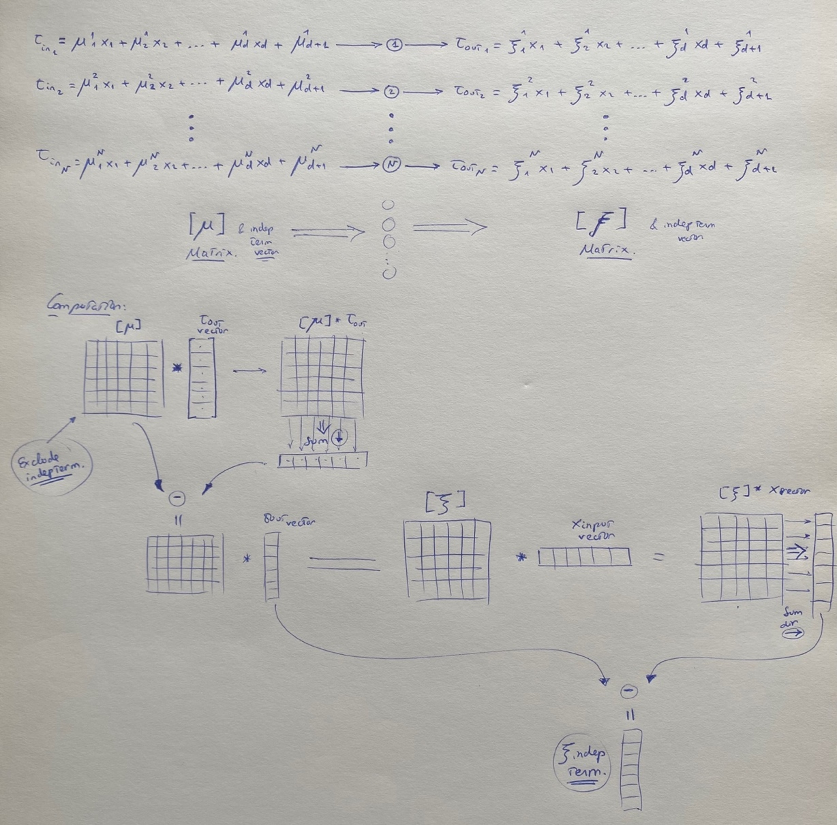

**Code:**

# Softmax (not normal, uses info of all the activation functions in the layer):

def afs_softmax(in_slopes_mat, afs_out_vec, x_in_vec):

# afs_out_vec must be a column vector, x_in_vec must be a row vector:

afs_out_vec = afs_out_vec.reshape((-1, 1))

x_in_vec = x_in_vec.reshape((1, -1))

# Get the matrix of slopes for the outputs:

sum_of_prod_1 = np.sum(np.multiply(in_slopes_mat, afs_out_vec), axis =0)

diff_1 = np.subtract(in_slopes_mat, sum_of_prod_1)

out_slopes_mat = np.multiply(diff_1, afs_out_vec)

# Get the vector of independent terms for the outputs:

sum_of_prod_2 = np.sum(np.multiply(out_slopes_mat, x_in_vec), axis=1).reshape((-1, 1))

out_indeps_vec = np.subtract(afs_out_vec, sum_of_prod_2)

return out_slopes_mat, out_indeps_vec

[**softplus(...)**](https://www.tensorflow.org/api_docs/python/tf/keras/activations/softplus)**: Softplus activation function, softplus(x) = log(exp(x) + 1).**

**Definition:**

$$t_{out}=\log\left(\exp\left(t_{in}\right)+1\right)$$

**Derivative:**

$$u=\frac{\exp\left(t_{in}\right)}{\exp\left(t_{in}\right)+1}=\frac{1}{1+\exp\left({-t}_{in}\right)}$$

$$v= t_{out}-u∙t_{in}$$

**Code:**

# Softplus:

def af_softplus(af_in, af_out):

u = 1/(1+np.exp(-af_in))

v = af_out - u*af_in

return u, v

[**softsign(...)**](https://www.tensorflow.org/api_docs/python/tf/keras/activations/softsign)**: Softsign activation function, softsign(x) = x / (abs(x) + 1).**

**Definition:**

$$if t_{out}<0: t_{out}=\frac{t_{in}}{1-t_{in}}=\frac{1}{t_{in}^{-1}-1}{=\left(t_{in}^{-1}-1\right)}^{-1}$$

$$if t_{out}≥ 0: t_{out}=\frac{t_{in}}{1+t_{in}}=\frac{1}{t_{in}^{-1}+1}={\left(t_{in}^{-1}+1\right)}^{-1}$$

**Derivative:**

$$if t_{out}<0: u{=-\left(t_{in}^{-1}-1\right)}^{-2}\left(-t_{in}^{-2}\right)=\frac{1}{{\left(t_{in}^{-1}-1\right)}^{2}{\left(t_{in}\right)}^{2}}=\frac{1}{{\left(1-t_{in}\right)}^{2}}={\left(1-t_{in}\right)}^{-2}$$

$$if t_{out}≥ 0: u={\left(1+t_{in}\right)}^{-2}$$

So, we can group as:

$$u={\left(1+abs(t_{in})\right)}^{-2}$$

$$v= t_{out}-u∙t_{in}$$

**Code:**

# Softsign:

def af_softsign(af_in, af_out):

u = (1+np.abs(af_in))**(-2)

v = af_out - u*af_in

return u, v

[**swish(...)**](https://www.tensorflow.org/api_docs/python/tf/keras/activations/swish)**: Swish activation function, swish(x) = x * sigmoid(x).**

**Definition:**

$$t_{out}=\frac{ t_{in}}{ \left(1 + exp\left(-t_{in}\right)\right)}=t_{in}∙ sigmoid\left(t_{in}\right)$$

**Derivative:**

$$u=sigmoid\left(t_{in}\right)+t_{in}∙{\left[sigmoid\left(t_{in}\right)\right]}^{'}=sigmoid\left(t_{in}\right)+t_{in}∙sigmoid\left(t_{in}\right)\left(1-sigmoid\left(t_{in}\right)\right)=$$

$$=sigmoid\left(t_{in}\right)\left[1+t_{in}∙\left(1-sigmoid\left(t_{in}\right)\right)\right]$$

Note that

$sigmoid\left(t_{in}\right)=\frac{t_{out}}{t_{in}}$

So

$$u =\frac{t_{out}}{t_{in}}\left[1+t_{in}∙\left(1-\frac{t_{out}}{t_{in}}\right)\right]= \frac{t_{out}}{t_{in}} \left[1+t_{in}-t_{out}\right]$$

Then:

$$v=t_{out}-u∙t_{in}$$

**Code:**

# Swish:

def af_swish(af_in, af_out):

u = (af_out/af_in) * (1+af_in-af_out)

v = af_out - u*af_in

return u, v

[**tanh(...)**](https://www.tensorflow.org/api_docs/python/tf/keras/activations/tanh)**: Hyperbolic tangent activation function.**

**Definition:**

$$t_{out}=tanh(t_{in})$$

**Derivative:**

$u={sech}^{2}\left(t_{in}\right)=\cosh^{-2}\left(t_{in}\right)$

$$v= t_{out}-u∙t_{in}$$

**Code:**

# Tanh:

def af_tanh(af_in, af_out):

u = (np.cosh(af_in))**(-2)

v = af_out - u*af_in

return u, v